ICOMOS Slovenia
Heritage at Risk Report

- General report
When speaking about the cultural heritage that is most at risk in Slovenia it is first necessary to highlight the heritage from the 19th and 20th centuries. Despite intensive efforts of a small group of experts, this heritage still remains misinterpreted and thus left to intensive interventions, which in turn have a detrimental effect on it and significantly change its testimonial value.
This year’s report is focused on a few cases from Ljubljana, which has been as a capital city the most active construction-wise and, as a result, its heritage is greatly exposed as well.
Since the mid-19th century Ljubljana grew from a provincial town on the margins of the Austro-Hungarian Monarchy to a national capital and precisely the architecture and the bold urban planning solutions of the major Slovenian architects influenced its high-quality urban life and also its visibility. The spatial development of Ljubljana was importantly shaped by Camillo Sitte (1843–1903) and Maks Fabiani (1865-1962) after the great 1895 earthquake, Jože Plečnik (1872–1957) between the two world wars, and Edo Ravnikar (1907–1993) in the second half of the 20th century. The work of other architects was significant as well: France Tomažič (1899–1968), Vladimir Šubic (1894–1946), Edo Mihevc (1911–1985), Danilo Fuerst (1912–2005), Stanko Kristl (1922–), Savin Sever (1927–2003) Miloš Bonča (1932–2007), to mention just a few.
Nevertheless, the work that left the most indelible mark on the city was that of Jože Plečnik, with his thoughtful planning, where he delicately connected spatial ambiences and temporal layers into rich, magnificent ambiences, never disloyal to the measure of man. During his more than 20 years of intensive creation, he developed solutions which have provided the backbone of the life in the city centre. He designed the key city axes – the pedestrian routes in the city centre – and upgraded them with architecture, which complements, upgrades, and connects them in terms of design and programmatically. Prešernov trg (Prešeren’s Square) with Tromostovje (The Three Bridges) is one of the key locations of this connectivity and of the opening outward and along the city paths and the Ljubljanica River, which he dedicated special attention. So today, after one hundred years since the design of the first plans and implementations of Plečnik’s Ljubljana, we speak of it as a monument to timeless urban humanity, which is also why the nomination of the most important monuments of this urban landscape is being prepared, which will put this these buildings on the world heritage list.
The central figure of the second half of the 20th century was Edvard Ravnikar, Plečnik’s pupil, who worked in Le Corbusier’s atelier for a short period of time. His works include the Trg republike (Republic Square), as the new centre of the modern city, the Ferantov vrt (Ferant Garden) residential quarter, and many studies and competition entries for the redesign of the city centre. His pedagogical role at the University of Ljubljana was paramount; there he raised generations of architects who with their work, particularly in the 1970s, lay the foundation for what is now called the Ljubljana school of architecture.
The spatial development during socialism was planned and manageable and many high-quality urban architectural solutions emerged which were the consequence of a quality development of the profession throughout Yugoslavia; these circumstances greatly differed from the conditions witnessed in other Eastern European socialist countries. Nevertheless, after the change of the political system in 1991 these conditions changed as well.
Democratisation also broke away with the state-managed planning, which was logical, but this also meant a discontinuity of the appropriately guided spatial planning, at least for a while, i.e. until a new system was set up – this greatly influenced the preservation of quality in spatial design and architecture. The previously public investments were replaced by private capital, which no longer followed the previously set standards, while new ones took time to take shape. In the 1990s many private multi-dwelling projects were built, which lacked any outdoor green areas and the necessary social infrastructure (kindergartens, primary schools, shops, health care centres). The life in the neighbourhoods built during socialism, which had an appropriate infrastructure, became less interesting, regardless of the quality. This was a period when practically in each larger Slovenian town big, over dimensioned industrial business zones and commercial centres were built, also in highly unsuitable locations, because in this way the state wanted to speed up the economic growth. This irreparably marked spatial development. The sites of bankrupt industrial enterprises on the other hand mostly ended up in the hands of private investors. High-quality industrial architecture, which represented an important industrial heritage, was torn down in many places, because the politics did not want to become an obstacle to the capital in any way.
Transition conditions brought the loss of many important architectures of the 20th century, particularly those that emerged during socialism. This led to organisation of architects and the first public campaigns to preserve the most significant heritage of modernism. The result is undoubtedly awareness raising at least among some of the professional community but, as explained in the introduction, there are still not many efficient systemic solutions in place at the state level, as public heritage protection services do not have enough well-trained experts who could follow the current needs. A large problem has been unprofessional implementation of energy performance improvements, which we have witnessed over recent years. Under the Ministry of Culture, experts have prepared guidelines to improve the energy performance of cultural heritage buildings; however, the post-war Modernism and industrial heritage buildings are highly specific and require special refurbishment projects. These projects are prepared on an exceptional basis, while the decisions about the refurbishment of significant buildings, particularly apartment buildings, are made by the owners and their managers, while the experts from the Institute for the Protection of Cultural Heritage of Slovenia are included only rarely, as this heritage still lacks proper legal protection.
- Case Studies
New political and economic conditions brought about the first extensive private investments in heritage sites, which have largely revealed to be problematic, particularly due to the unrealistic expectations of the investors and the political support, even though the investments generally did not consider urban planning conditions and cultural heritage protection conditions. The projects were mostly prepared in a way that prompted the subsequent coordination with the competent services and the changes to spatial documents, which has been done in practice, however this led finally led to making compromises at the expense of heritage. It is difficult to comment how the many solutions were accepted. Disagreement with intensive construction and professional decisions led to the establishment of various civil initiatives. The most active were the initiative that opposed the construction of underground car parks at Ljubljana Markets adjacent to the Plečnik Colonnade, the initiative to preserve Plečnik’s stadium at Bežigrad in its original form, and the initiative committed to prevent the restoration of Vegova Street in line with Plečnik’s project as this would mean the removal of trees that have grown to an extent where the urban design itself is put at risk.
Many major investment cases in the city centre were stalled because of the financial crisis and investments that went beyond the investors’ capacity, nevertheless, the initiatives’ activities helped everyone to again rethink the situation. City professional services were also involved in the pursuit of quality solutions, at least in some locations, as this was the only way to speed up the procedures and resume the work in many abandoned construction sites in the centre of the city. The following cases need to be particularly mentioned: Kolizej, Tobačna tovarna (the Tobacco Factory) and, the most notorious one, the refurbishment of the Stadium at Bežigrad, which will be presented in more detail.
Kolizej was one of the earliest mixed-use building in the world. Dating back to 1848 it was built to the design of the Graz entrepreneur and architect Johan Benedikt Withalm (1771–1865), designed in the sense of a transitional barracks for the army who occasionally came to Ljubljana as well as for the needs of social life of the former citizens. Along with the barracks, the building houses several halls for various events, areas for socialising, dining areas, and an inn. In the late 20th century, Kolizej was in a very poor condition since nobody invested in it, except for a few residents who lived in the apartments in the tract at Gosposvetska. In 1995 part of the building with the main hall even collapsed because of the users’ interventions into the structure. The building was then bought by a private investor and in 2004 the investor held a an international design competition for a new construction in the area of the building that had the status of a cultural monument of national importance, while the existing spatial documents and cultural protection background were not considered. The Dutch Neutelings Riedijk Architects won the competition, whose design greatly intervened with Ljubljana’s identity cityscape, so in the harmonization phase it failed to acquire the necessary construction permits. However, the owner managed to tear down the building despite its exceptional qualities already back in 2011, acquiring a new project that still does not achieve the qualities that it should, given the significance of the location.
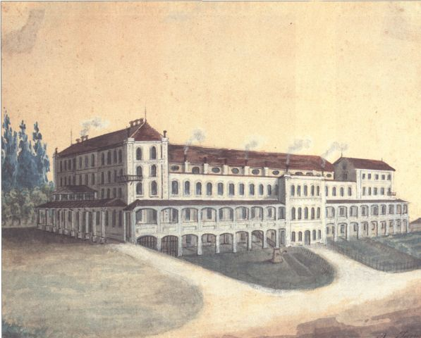
Figure 1: Kolizej in the mid-19th century as depicted by Anton Jurmann. Source: https://sl.wikipedia.org/wiki/Kolizej,_Ljubljana#/media/Slika:Kolizej_in_Ljubljana_in_middle_of_19th_century.jpg
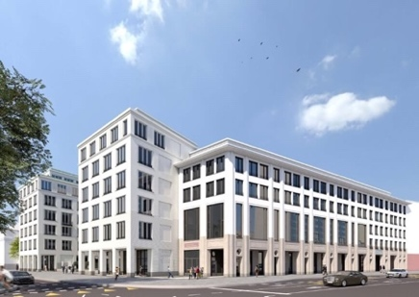
Figure 2: The project for the Schellenburg palace to be erected at the site of the demolished Kolizej. Source: https://www.gravitas.si/projekt/stavbe/aktualno/palaca-schellenburg

The revitalisation of the abandoned Tobačna tovarna, which was built in the second half of the 19th century, then on the periphery and now in the very centre, has led, because of the investor’s ambitions and the not critical enough attitude of professional services and the Chamber of Architecture and Spatial Planning of Slovenia, to an over dimensioned project, whose realisation prompts the demolition of several original buildings in the heritage site, which had the potential to develop a content suitable for the city centre. The selected competition entry from the 2006 competition accommodated the requirements of the investor as much as possible; the project not only destroyed the important buildings of this industrial complex but had an adverse impact on the cityscape as well. This was not implemented because of the investor’s bankruptcy, but here as well an open construction site has remained for several decades with excavated underground garages with 3,600 parking places. Nevertheless, in the meantime the City Council adopted a decree on designation of the preserved buildings as monuments of local significance, and there are also discussions underway how to keep the programmes that occupied the space in the preserved buildings and are important for the city and adapt the project accordingly.
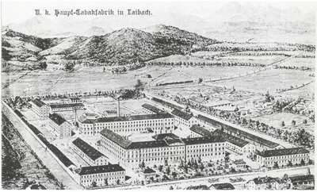
Figure 3: The Tobačna (‘Tobacco Factory’) as it once was. Source: Muzej novejše zgodovine Slovenije.
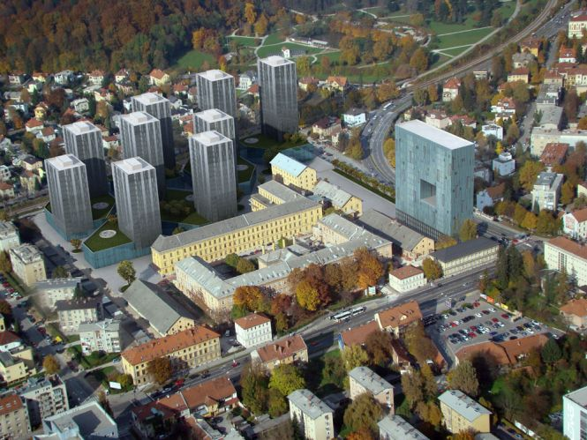
Figure 4: The first-prize winning entry in the public competition for restoration of the Tobačna tovarna site. Source: https://radiostudent.si/politika/offsajd/tobačna-mesto-postaja-center

The restoration story of the Central Stadium Bežigrad began with the bankruptcy of the central city football club Olimpija, which in the 2004/2005 season also stopped playing in the premier league. In the bankruptcy proceedings, its central property, i.e. the stadium, was bought by a Slovenian entrepreneur, who wanted to restore the stadium and upgrade it programmatically, as the city was practically left without a central football sports facility for major competitions, while the project also provided for an extensive additional commercial programme. To that end, in 2007 a public-private partnership consortium was established, together with the City of Ljubljana and the Slovenian Olympic Committee. The BŠP (Bežigrajski športni park) company was established, which was, with the majority share by Joc Pečečnik (GSA), the central investment vehicle. On its website, BŠP presents the project along with the project’s timeline.
The stadium was originally designed by Jože Plečnik in 1925 for the Catholic gym society Orel. The project was completed by his student Ivan Pengov. In 1935 it was changed for the first time to the design of Jože Plečnik and expanded for the Eucharistic Congress, when the one-storey gloriette and a visitors’ arena were added. After the war the stadium was intended for sporting events, a track was added and the stadium was adapted to the needs of the Olimpija football club. The stadium fully closed down in 2008 when the restoration was supposed to start to the design of GMP architects (Architekten von Gerkan, Marg und Partners) from Berlin who won the invited competition, which was held together with the City of Ljubljana. The project includes the construction of a high-rise on the south side of the stadium, three business villas in its northern side, a two-storey gallery above the existing stands, and the facilities for the athletes and an underground car park below the stadium field. The jury comprising the representatives from the City of Ljubljana, Chamber of Architecture and Spatial Planning of Slovenia, Institute for the Protection of Cultural Heritage of Slovenia, and the investor unanimously selected the entry by the German GMP group. The investor acquired all the necessary permits and according to the competition solution the Municipal Detailed Spatial Plan (OPPN) was drawn.
In 2009, ICOMOS Slovenia provided a statement regarding the competition solution in a press release, underlining the following: “Despite the Institute for the Protection of Cultural Heritage of Slovenia’s confirmation of adequacy of the winning entry for the restoration of Plečnik’s stadium, we demand a re-evaluation of how cultural protection baselines are considered in order to allow for protection of Plečnik’s stadium in line with international provisions and legal protection of the cultural heritage.”
In 2011 a civil initiative was formed headed by some of the residents of the Fondovi bloki (Fund Apartment Buildings), which are at the same time a party to legal proceedings in determining plot ownership on the eastern side of the stadium, where the Slovenian Olympic Committee also has a claim. The initiative is trying the restore the original form of the stadium, which is of course not in line with the investor’s interests; such a solution gives rise to professional concerns as well, as even the project’s name itself does not take into account the 1925 expansion, when the stadium was extended to hold public assemblies. Given the length of the procedure and the many obstacles, the investor put the stadium up for sale, but there are unfortunately no private nor public resources that would allow for a restoration, which would be more appropriate than the one already planned.
In 2014 the project was issued a negative environmental report due to noise pollution during construction, which brought the procedures to a stop until to adoption of the new construction legislation in 2018, in line with which BŠP re-applied for a building permit, while new cultural protection documentation is also being re-acquired, i.e. culture protection guidelines. The fact is that in 2009 the Plečnik stadium was declared a monument of national significance. It is not clear how this will be taken into account when acquiring new guidelines by the Institute for the Protection of Cultural Heritage of Slovenia. It is necessary to thoroughly think about the admissibility of such intensive interventions as those permitted by the 2008 conservation plan. It is particularly necessary to rethink the acceptability of building the galleries above the stands and the extent of the garages, whose construction will affect the static stability of the gloriette as the central motif of Plečnik’s renovation. During the time when the necessary permits were being acquired the monument was not appropriately maintained and it deteriorated.
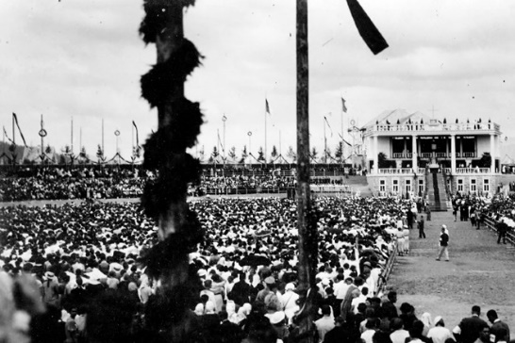
Figure 5: The gloriette on the stadium was erected in 1935, when it was adapted for the needs of the Eucharistic Congress. Source: Muzej in galerije mesta Ljubljane.
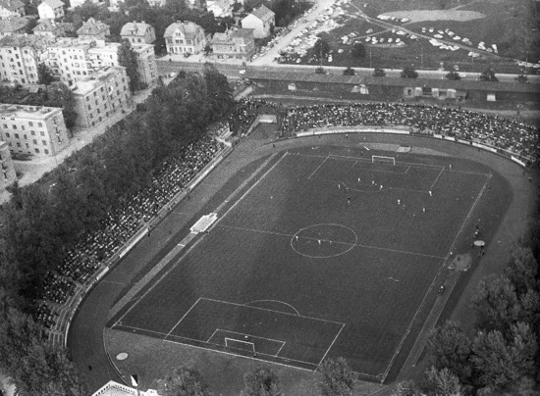
Figure 6: The stadium around 1965. Photo: Edi Šelhaus, from Muzej novejše zgodovine Slovenije archives.
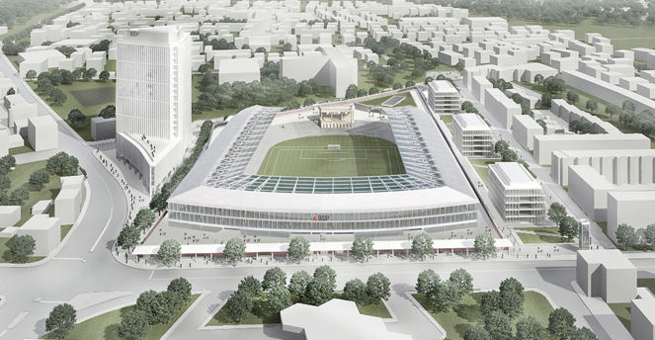
Figure 7: Wining project of the international competition, Architekten von Gerkan, Marg und Partners, 2008. Source: http://bsp.si
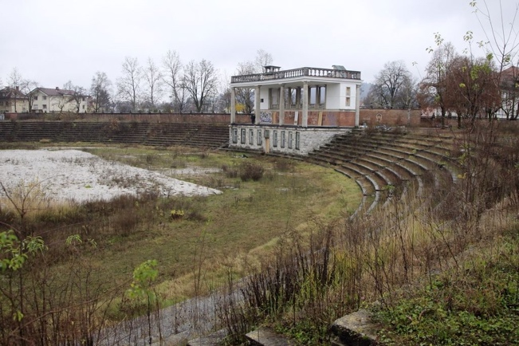
Figure 8: The stadium in 2008. Source:
https://radiostudent.si/sites/default/files/slike/2018-06-19-mnenje-kot-resnica-88515.jpg

When looking at the chronology and the duration of the procedures for restoration of the Bežigrad stadium, which have taken more than 12 years, it is necessary to establish a responsible attitude of everyone involved toward the investor, who, despite everything, has stood by the project that the professional committee unanimously selected at the competition. And precisely the competition is the point to which we must return if in the future we want to improve the conditions regarding the interventions into cultural heritage. Professional services must have clearly-defined criteria and assessment of the individual monuments or heritage in the decision-making phase on the selection of the restoration projects, and their voices must be heard and respected throughout the procedure. In turn, they are given the responsibility to carry out a high-quality professional work. The current adjustments to the investors – as this is the only way to understand some professional decisions – have revealed to be counterproductive in all the cases presented – and also in other cases not mentioned in this report, as they brought serious damage to everyone involved, investors included, but mostly to the heritage. ICOMOS stressed this already back in 2009 in the aforementioned press release.

- Conclusions
The role of the conservation profession in Slovenia must be strengthened, and particularly adequate budget and staff must be provided, who will be able to prepare the necessary materials in a research and professional manner. The work of both key ministries directly involved with the restoration projects, i.e. the Ministry of the Environment and Spatial Planning and the Ministry of Culture, must be coordinated. Also, the involvement of Slovenian researchers from universities and research institutions concerned with heritage protection is too small, particularly in actual research tasks of evaluating the heritage and drawing-up protection guidelines.
ICOMOS Slovenia as a non-governmental organisation in the public interest is trying to work in a connecting and constructive manner as much as possible. We organise various conferences, e.g. a 2016 conference on the topic of refurbishing Plečnik’s stadium, we have also prepared several events open to both professional and general audiences, which expose the significance of cultural heritage protection and the potentials that it offers for development. In this context it is important to mention two documents that can be helpful to anyone involved in the planning or decision-making regarding the restoration projects, i.e. European Cultural Heritage Strategy for the 21st Century of the Council of Europe and the European Quality Principles for EU-funded Interventions with Potential Impact upon Cultural Heritage. The fact is that people are increasingly aware (investors included) that the heritage has an important economic potential and how it is important to understand all of its dimensions and the necessity to invest in it – instead of short-term profits this contributes in the long-term both to the economy and the society. This report was also complied to create better conditions for the heritage in the future. ICOMOS Slovenia also aims to arrange for the earliest possible translation of the European Quality Principles for EU-funded Interventions with Potential Impact upon Cultural Heritage, which will particularly support the designers of all projects concerned with heritage protection, not only those financed by the European Union.

Sonja Ifko
President of ICOMOS Slovenia

This was stressed by the exhibition Concrete Utopia, which was held 2018 in MOMA in New York, which included the creation of the Yugoslav architecture of the second half of the 20th century in the wider, world context. An extensive monograph with the same title was published to accompany the exhibition.
Vendramin, Mojca et al. (2016). Smernice za energetsko prenovo stavb kulturne dediščine, Ljubljana : Ministrstvo za infrastrukturo : Ministrstvo za kulturo. Link: https://www.gov.si/assets/ministrstva/MK/DEDISCINA/NEPREMICNA/smernice_kd-final.pdf
The first building of this kind was built by Withalmearlier on in Graz, which however was deteriorated at the turn of the 19th and the 20th centuries. His work also includes the Iron House (1846), also in Graz, with a cast-iron facade construction. Part of the building is integrated in the Kunsthaus complex by Peter Cook and Colin Fournier.
A roundtable on the future of Tobačna was organised by the Institute for Spatial Policies in April 2019. More at: https://ipop.si/2019/04/04/kaj-bo-s-tobacno-preberi-tukaj/
http://bsp.si/
The full text of the press release is published at the ICOMOS Slovenia website: www.icomos.si

